SCUBA-2 Block Specification
offset/sa_bias_ctrl

April 4, 2005
Table of Contents

1. Block Overview 4
1.1 Block Location and Block Interface Within System 4
1.2 Block Functionality / Features 4
1.3 Block Dataflow 4
2. Block Interfaces 6
2.1 Interface Signal Description 6
2.2 Interface Protocol and Timing 7
3. High-Level Description 9
3.1 Offset/Sa_Bias Clock Domain Crosser (offset/sa_bias_clk_domain_crosser) 9
3.2 Offset/Sa_Bias Serial Peripheral Interface (offset/sa_bias_spi_if) 9
4. Files of the Block 11
4.1 Source Code 11
4.1.1 Offset/Sa_bias_ctrl.vhd 11
4.1.1.1 Offset/Sa_bias_clk_domain_crosser.vhd 11
4.1.1.2 Offset/Sa_bias_spi_if.vhd 11
4.2 Header Code 11
4.2.1 Offset/Sa_bias_ctrl_pack.vhd 11
5. Naming Conventions Used 12

Table of Figures

Figure 1: Offset Control Block 4
Figure 2: SA Bias Control Block 5
Figure 3: Interface Timing Diagram 1-1 7
Figure 4: Interface Timing Diagram 1-2 8
Figure 5: Offset/Sa Bias Clock Domain Crosser Block Diagram 9
Figure 6: Offset/Sa Bias SPI Block Diagram 10

Block Overview

Block Location and Block Interface Within System
The offset/sa_bias control (offset/sa_bias_ctrl) block is instantiated inside each flux loop control block (flux_loop_ctrl) found on the readout card. On each card, there are eight flux_loop_ctrl blocks responsible for the eight different channels.
The offset/sa_bias control (offset/sa_bias_ctrl) stands alone in their datapaths separate from the first stage feedback control system datapath. Its upstream input side is interfaced with the offset/sa_bias control data registers found inside the wishbone feedback data block while its downstream output side is interfaced with the 3-bit Serial Peripheral Interface (SPI) of the Digital-to-Analog-Converter (DAC) hardware.

Block Functionality / Features
For every frame, the offset/sa_bias control block is responsible for fetching the offset/sa_bias control data input from the wishbone feedback data and sending the value down to the DAC through the SPI. It has the following main features:
- Captures the restart_frame_aligned-related trigger input and safely transfers it from the 50MHz to 12.5MHz clock domain.
- Samples the parallel 32-bit (only the lower 16 bits are used) offset/sa_bias control values upon each SPI write transfer start
- Serially converts the parallel input and outputs the serial data in conformance with the DAC hardware SPI write specification

Block Dataflow
Figure 1 and Figure 2 show the block dataflow for the offset/sa_bias control (offset/sa_bias_ctrl) block. Note that the offset and sa_bias control shares the same architecture.

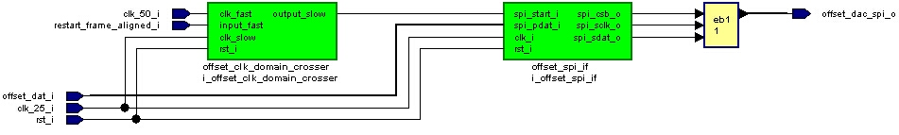
Figure 1: Offset Control Block

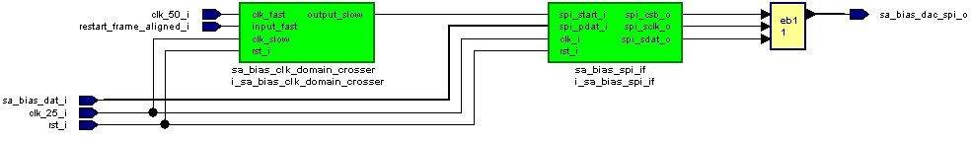
Figure 2: SA Bias Control Block

Block Interfaces

Interface Signal Description
- Interface Signals
Signal | Description | Direction
rst_i | Global block reset | in
clk_25_i | Global clock (12.5MHz) used by the DAC SPI | in
clk_50_i | Global clock (50MHz) used by the system | in
restart_frame_aligned_i | Indicates next clock cycle is the start of frame (one clk period pulse), see note for actual use. | in
offset/sa_bias_dat_i | Offset/SA bias wishbone control data input | in
offset/sa_bias_dac_spi_o | Offset/SA bias control DAC SPI interface output | out

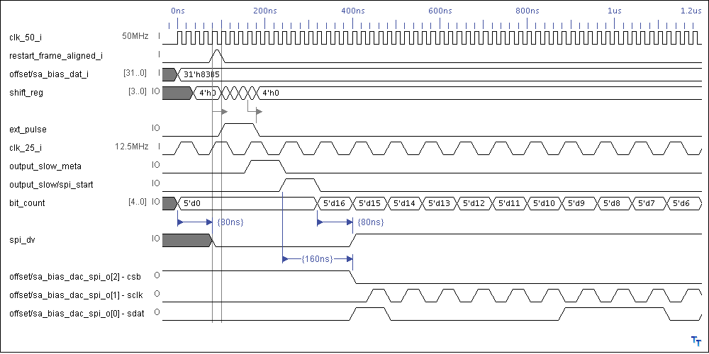
Interface Protocol and Timing

Figure 3: Interface Timing Diagram 1-1
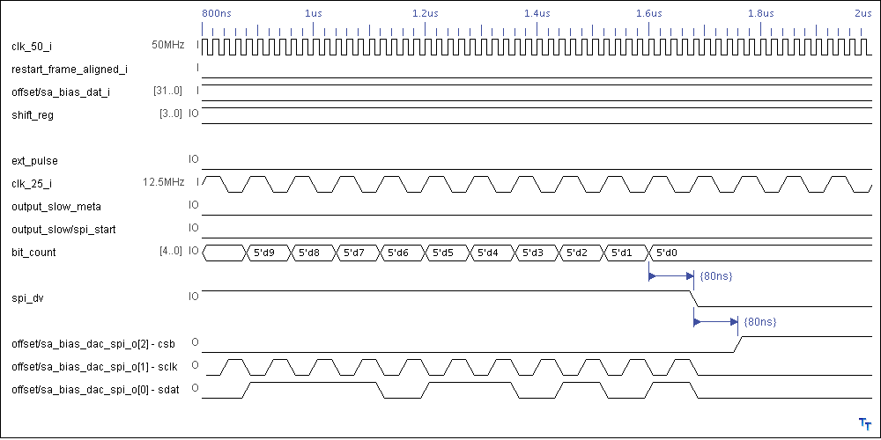

Figure 4: Interface Timing Diagram 1-2

High-Level Description

Offset/Sa_Bias Clock Domain Crosser (offset/sa_bias_clk_domain_crosser)
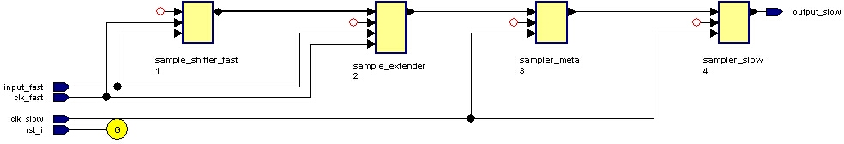
The clock domain crosser component is responsible for bridging the 50MHz system clock and the 12.5MHz clock domains. Because the maximum safe serial clock frequency for the DAC hardware is limited to 12.5MHz (according to PCB engineer), the “spi_start” derived from the “restart_frame_aligned”-related signal in the 50MHz clock domain must be safely transferred to the 12.5MHz clock domain. This is accomplished by extending the input pulse (sample_extender) by enough 50MHz clock cycles using a 4-bit shift register (sample_shifter_fast). To avoid metastability, the extended pulse is doubly registered (sampler_meta and sampler_slow) in the 12.5MHz clock domain with output finally taken from the second register. Figure 5 shows the block diagram of the clock domain-crossing component.

Figure 5: Offset/Sa Bias Clock Domain Crosser Block Diagram

Note that the 12.5 and 50MHz clocks are phase-locked, provided both are sourced from the same FPGA PLL. The clock domain crosser design, however, does not assume any phase relationship. In addition, the clock frequency relationship for this block is configured by a generic, “NUM_TIMES_FASTER”. The value of the generic is defined in the respective offset/sa_bias_ctrl_pack VHDL files.

Offset/Sa Bias Serial Peripheral Interface (offset/sa_bias_spi_if)
The serial peripheral interface is responsible for performing a standard SPI write upon the “spi_start” signal input. As mentioned, the “spi_start” is derived from the restart frame-related timing signal. Therefore the 16-bit parallel data input value to the DAC is sampled every frame (data_reg_proc) and then being serially converted (spi_sdat_proc). To avoid any conflict, configuration changes to the “offset_dat” or “sa_bias_dat” inputs inside the wishbone feedback data block are best done in the middle of a frame, away from the frame boundary. Because the DAC only supports an input data width of 16 bits, the upper 16 bits from the wishbone interface are ignored.

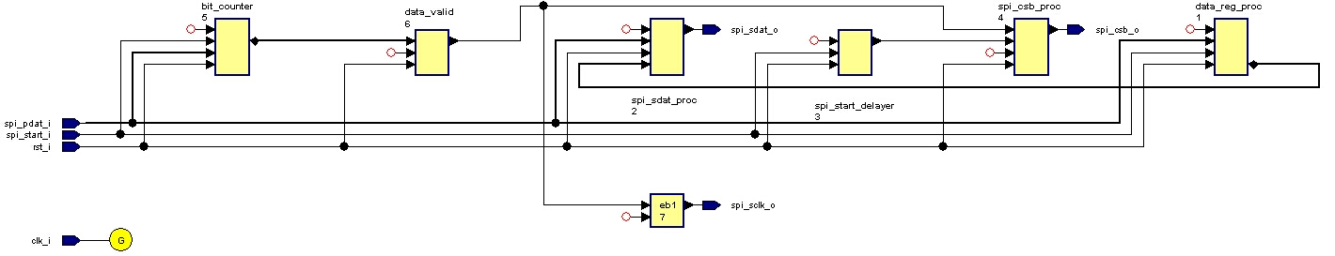
Figure 6: Offset/Sa Bias SPI Block Diagram

Figure 3 and Figure 4 together show an example of a complete SPI write transfer from the wishbone to the DAC hardware over the SPI with timing relationship details. Note that the SPI output serial clock is the inverted version of the 12.5MHz input clock within the active “spi_dv” window (data_valid). The window is active when sampling a non-zero bit count (bit_counter). This satisfies the DAC setup time requirement for its serial data input. Figure 6 shows the block diagram of the serial peripheral interface (SPI).

Files of the Block

Source Code

Offset/Sa_bias_ctrl.vhd
This is the top-level component for the offset/sa_bias control.

Offset/Sa_bias_clk_domain_crosser.vhd
This is the clock domain crossing component for the offset/sa_bias control’s SPI write transfer start signal.

Offset/Sa_bias_spi_if.vhd
This is the write serial peripheral interface (SPI) component for the offset/sa_bias control.

Header Code

Offset/Sa_bias_ctrl_pack.vhd
This is the package file for the offset/sa_bias control. It contains all the constant and component declarations used.

Naming Conventions Used

In the actual instantiation of the offset and sa_bias control blocks, the restarted_frame_aligned_i input signal is separately connected to the restart_frame_1row_prev (by offset) and post (by sa_bias). This is done to avoid bus contention because the bias_dac_dat and dac_clk lines are shared at the readout_card top level.

